IN CASE OF EMERGENCY
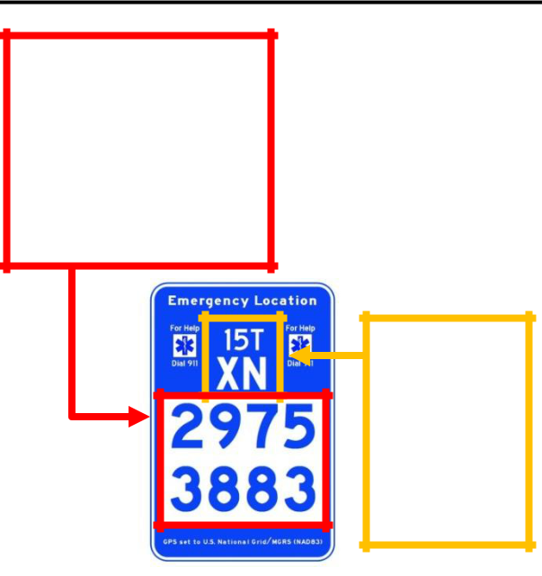

Fig. 1

Read numbers

left to right,

top row,

then bottom row

Fig. 2

Only read

text at top

if

requested

- Dial 911, tell them your emergency, and then read the 8 large numbers (Fig. 1) to describe your location. These numbers are USNG coordinates. If requested by the dispatcher, also read the small numbers and letters at the top (Fig. 2).

- Dispatchers can then quickly transmit your location to multiple agencies and responders in the region. Responders will use the coordinates with GPS units and USNG gridded maps to locate your position.

- Be patient. It may take some time for responders to reach you. In many cases, they will need to travel the same trails as you did to get to your location.

PROJECT PARTNERS
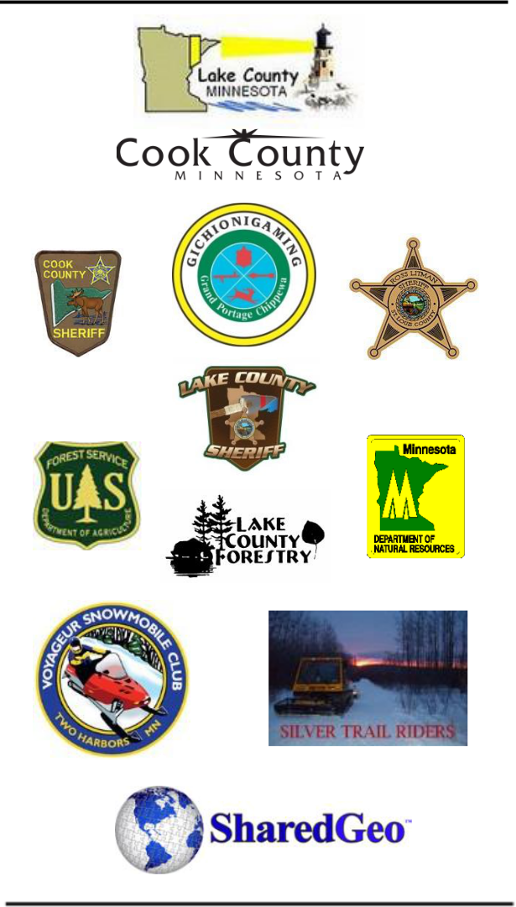

Tax deductible donations to this

project can be contributed at:

www.sharedgeo.org

(Look for: “Projects”)

(CC BY-NC-SA 3.0) 2010-2014, SharedGeo, Ver. 4

U.S. National Grid
TRAIL MARKERS

~ Arrowhead Region, MN ~
Cook, Lake and St. Louis Counties
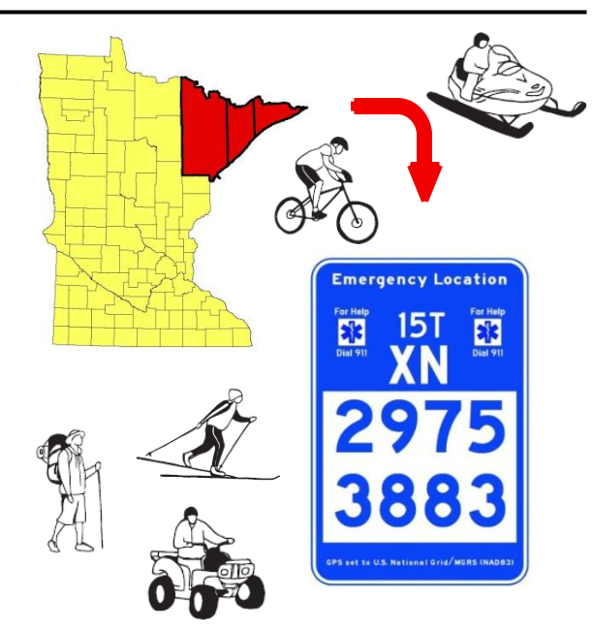

Until now, there hasn’t been a universal location marking system for recreational trails and other U.S. rural areas without formal street addresses.

U.S. National Grid (USNG) Emergency Location Markers are changing that.

These signs are GPS (Global Positioning System) compatible location markers that serve as an essential part of emergency response efforts.

READING USNG WITH A GPS
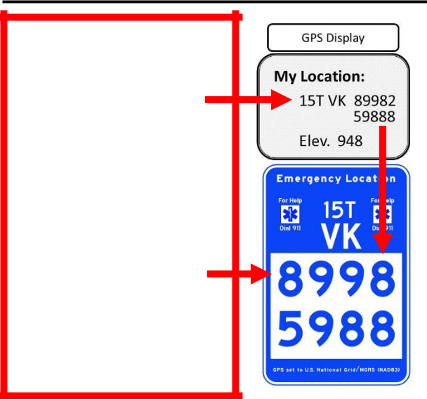

USNG Coordinates
on GPS

Most GPS units/apps show five digits for the

EASTING (e.g. 89982) and NORTHING (e.g. 59888) coordinates (1 meter precision).

USNG Emergency Location Markers only use the first four digits of the EASTING and NORTHING coordinates (10 meter precision).

The USNG is like the Military Grid Reference System (MGRS) – a location referencing and reporting system used by U.S./NATO Armed Forces for ground operations around the world because it is much easier to use accurately and less prone to human errors than latitude and longitude. GPS receivers use signals from a constellation of satellites to determine precise location information. When used together, USNG and GPS are an unbeatable combination.

USNG/MGRS GPS Selection:

If your GPS does not have USNG as an option, select MGRS and the North American Datum of 1983 (NAD83/WGS84) as your GPS default coordinate system to get on the USNG!

Rules of Thumb (GPS-Marker Interface):

1.) As shown in the example above, the first four digits of a GPS display Easting (8998) and Northing (5998) will match the marker.

2.) When reporting a GPS location away from a marker, use an 8 digit string (drop the last digit of the Easting and Northing shown on the GPS display). E.g., 89982 59886, becomes 8998 5988.

HOW THE USNG WORKS
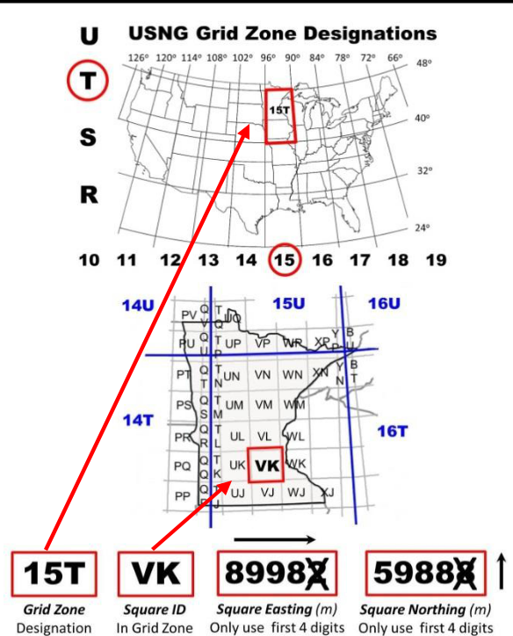

The USNG uses a string of up to 15 characters to describe a location. The first three characters are a GRID ZONE designation. Next, two letters identify a 100,000 meter SQUARE (100 km, about 62 miles square) in the GRID ZONE. Then come distances in meters (m) from the 100 km SQUARE’s lower left corner, RIGHT (Easting), THEN UP (Northing)!

These numbers roughly equate to a percentage

- of movement across a full square. The number of digits after the SQUARE’s ID determines the precision of the coordinate:

- FOUR DIGITS: 89 59 locates a point within a 1 km square (less than a mile).

- SIX DIGITS: 899 598 locates a point within a 100 m square (football field size).

- EIGHT DIGITS: 8998 5988 locates a point within a 10 m square (within a standard home).

- TEN DIGITS: 89982 59886 locates a point within a 1 m square (a manhole cover).

MORE ABOUT THE USNG

The USNG does not replace street names and addresses – it complements them. In case of emergencies in remote areas – or a natural disaster that destroys street signs and landmarks – emergency responders now have a universal language of geographic reference.
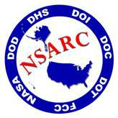

Used by the U.S. Military, National Guard units, and NATO for over 50 years, USNG/MGRS allows for quick communication and teamwork during operations where time and clarity of location information are life and death issues. FEMA, the National Geospatial Intelligence Agency, U.S. Geological Survey, and several other important disaster response organizations have recently started using USNG as a disaster response mapping standard. In November 2011, the National Search and Rescue Committee, a Federal committee which includes representatives from the Department of Defense, Commerce, Interior, Transportation, Homeland Security, as well as NASA, and the Federal Communication Commission, designated USNG as the standard for ALL ground based Search and Rescue (SAR) operations in the United States.

The Arrowhead Region of Minnesota is serving as the national test site for the USNG Emergency Location Marker project that supports overall implementation efforts. To obtain a copy of this brochure, or learn more about related tools, visit the “Markers” section of the USNG Information Center at:

usngcenter.org

